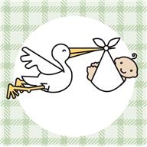 Guess That Baby Food  It Smells and Tastes Like….  - __________________________  - __________________________  - __________________________  - __________________________  - __________________________  Your Name: _______________________ | Guess That Baby Food  It Smells and Tastes Like….  - __________________________  - __________________________  - __________________________  - __________________________  - __________________________  Your Name: _______________________
Guess That Baby Food  It Smells and Tastes Like….  - __________________________  - __________________________  - __________________________  - __________________________  - __________________________  Your Name: _______________________ | Guess That Baby Food  It Smells and Tastes Like….  - __________________________  - __________________________  - __________________________  - __________________________  - __________________________  Your Name: _______________________
Guess That Baby Food  It Smells and Tastes Like….  - __________________________  - __________________________  - __________________________  - __________________________  - __________________________  Your Name: _______________________ | Guess That Baby Food  It Smells and Tastes Like….  - __________________________  - __________________________  - __________________________  - __________________________  - __________________________  Your Name: _______________________

